**IBM ASSIGNMENT-2**

**PHARMA SALES DASHBOARD**

|  |  |
| --- | --- |
| Assignment Date | 28 September 2022 |
| Student Name | Kavithanjali K |
| Student Roll Number | 953619104021 |
| Maximum Marks | 2 marks |

**Task:1 Sales By Customer**

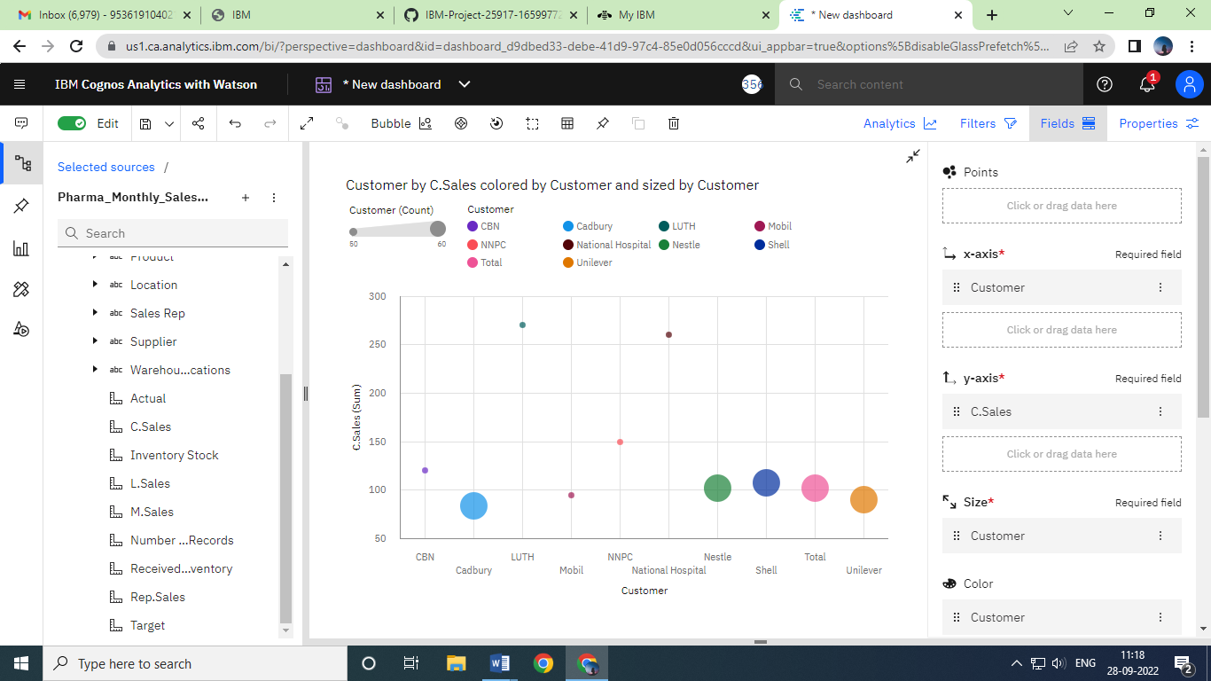  
**Task:2 Sales By Location**

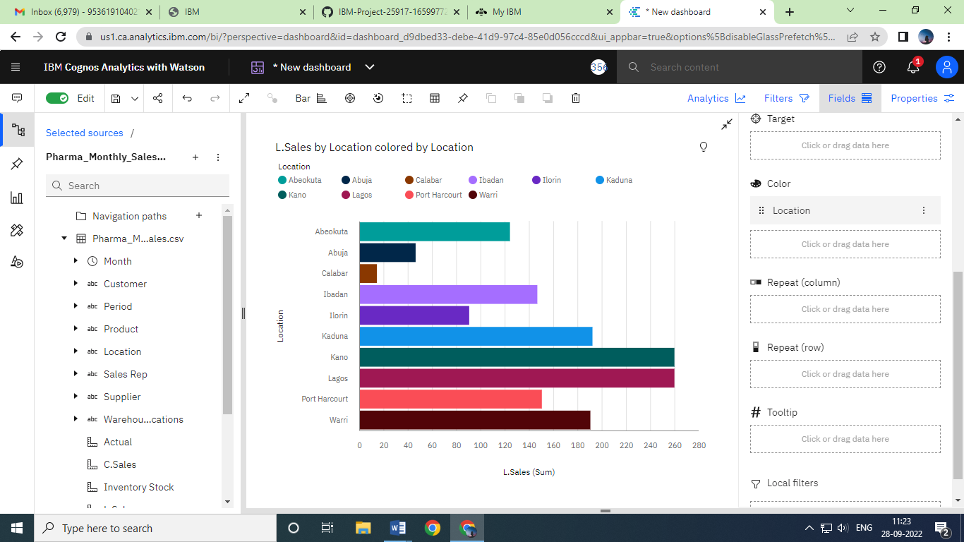

**Task:3 Sales By Sales Representative**

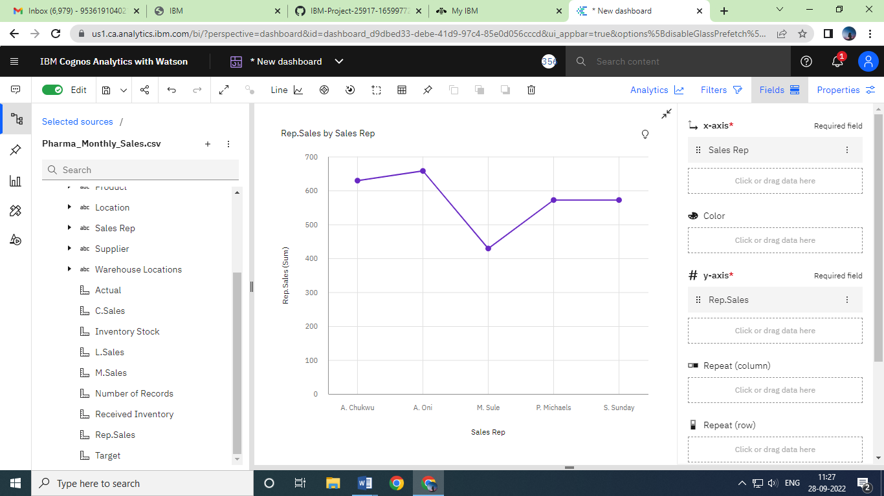

**Task:4 Received Inventory from Supplier**

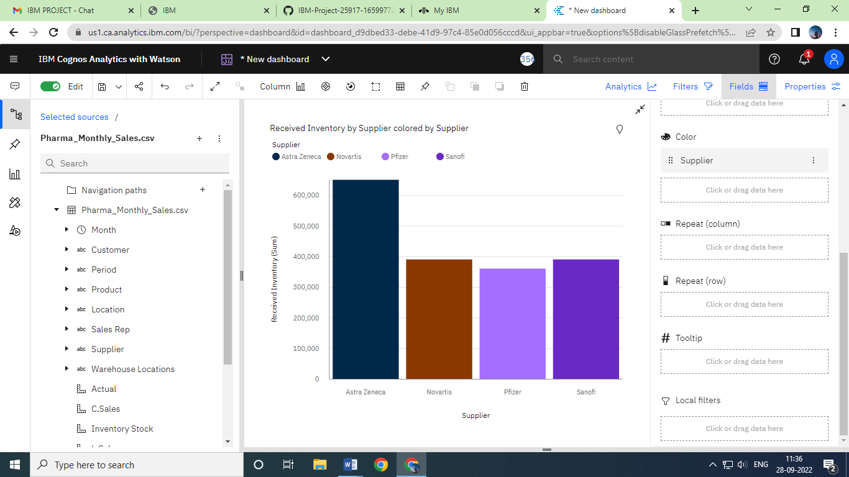

**Task:5 Inventory Stock for Warehouse Location**

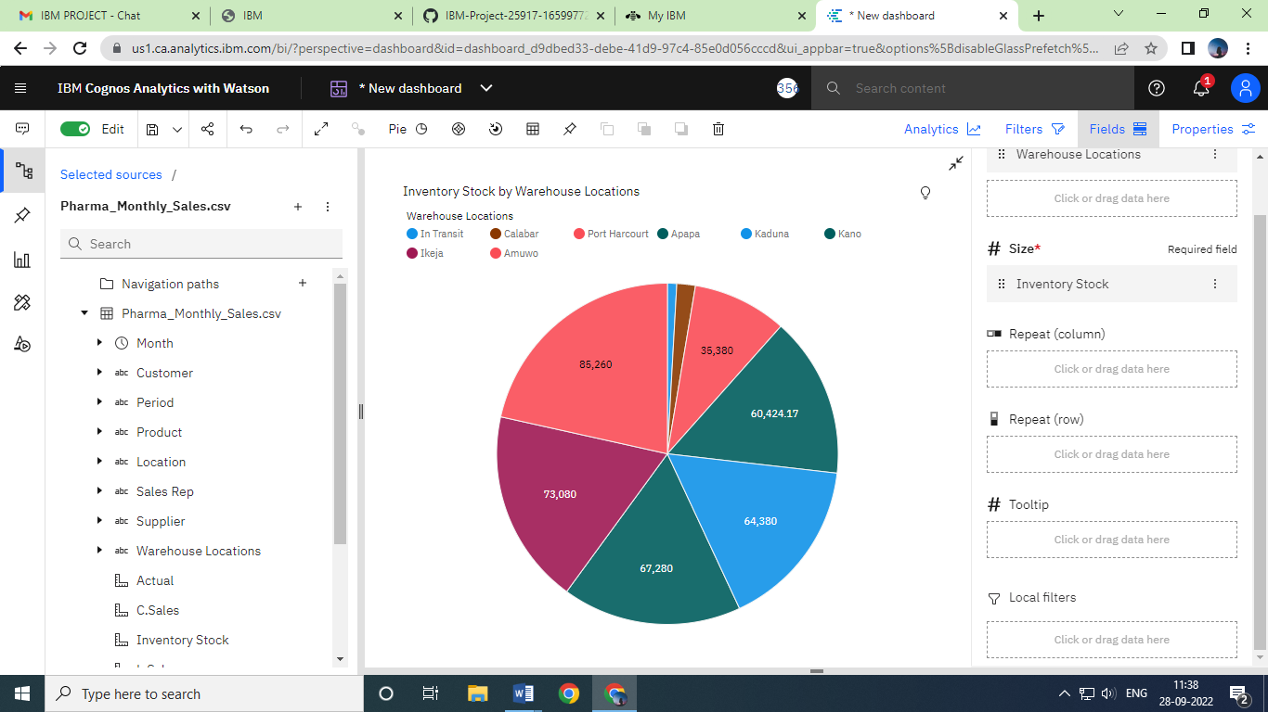

**Task:6 Sales Trend**

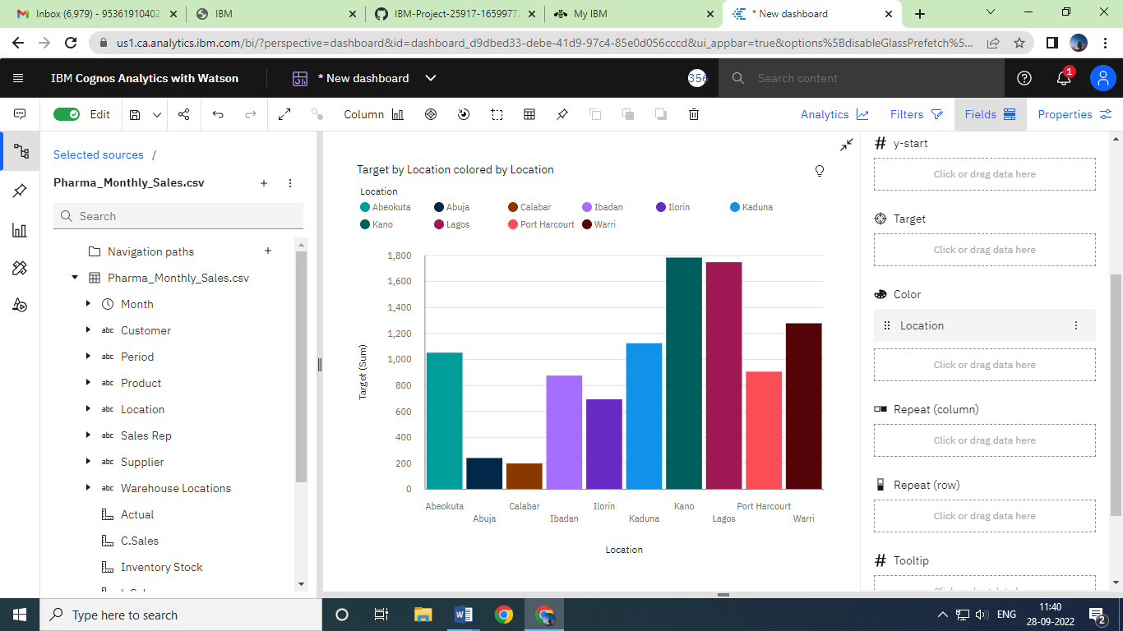

**Task:7 Monthly Sales**

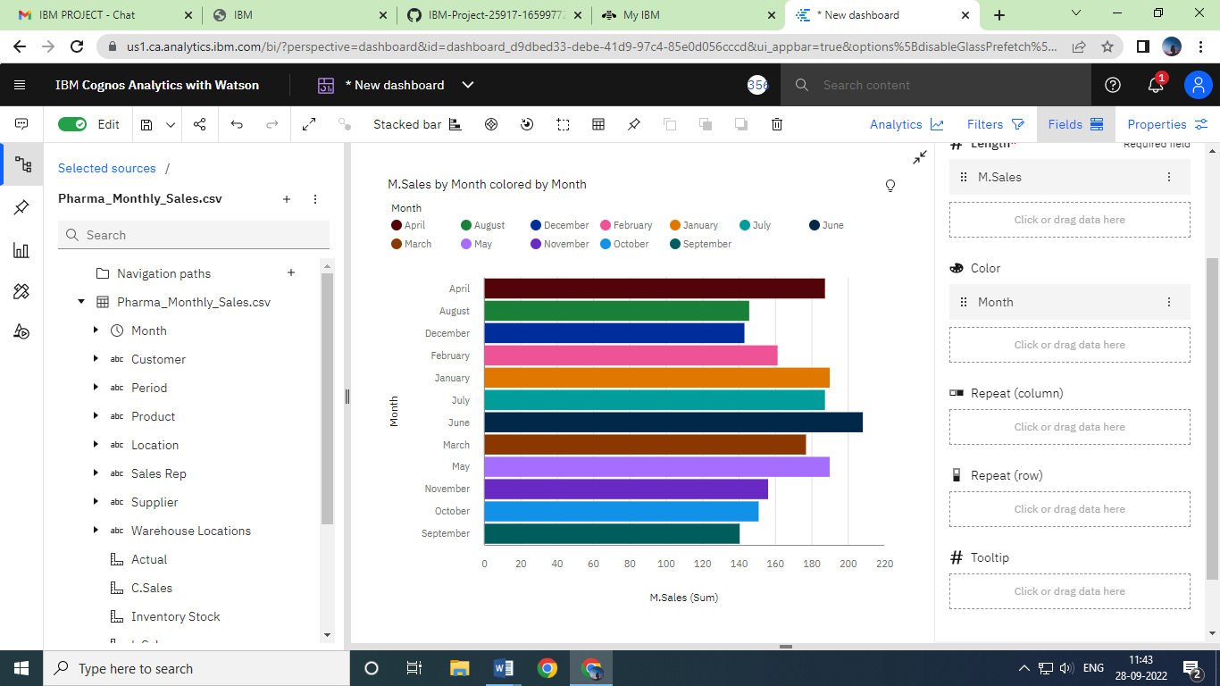

**Task:8 Actual and Received Inventory by Month**

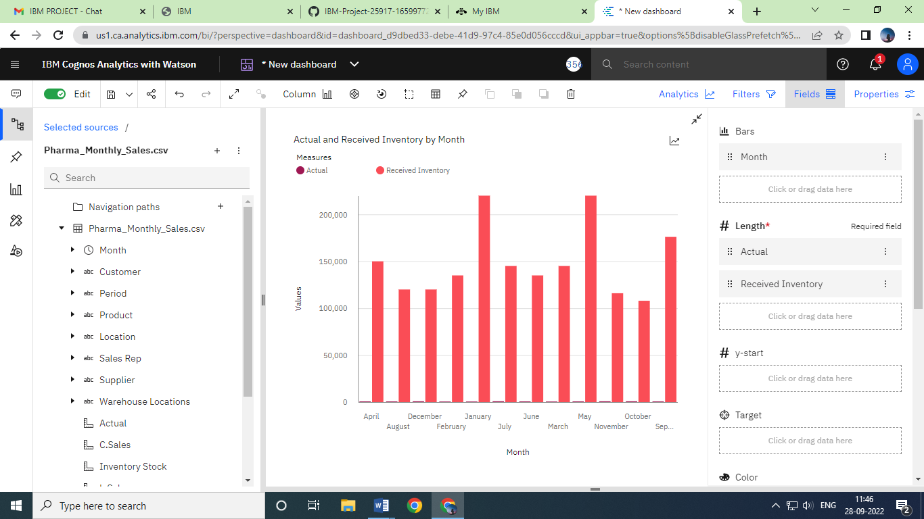

**IBM COGNOS DASHBORAD LINK:** <https://us1.ca.analytics.ibm.com/bi/?perspective=dashboard&pathRef=.my_folders%2FIBM%2BASSIGNMENT%2FIBM%2BASSIGNMENT%2B2&action=view&mode=dashboard&subView=model0000018382a05b7d_00000002>